RPG Attributes

# Initialise Attributes from a Data table

So far attributes have been initialised by calling init functions. This works, but it’s not the only way. Here’s an alternative

To make things more interesting we’ll add some more attributes to the AttributeSet

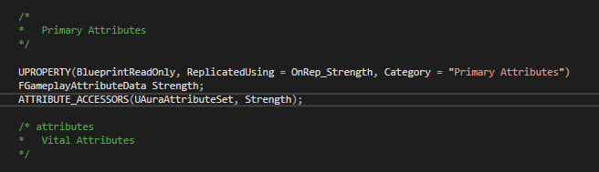

Example: Strength. Just copying the vital but changing the specifics. Note the On_Rep for a notif that does not yet exist

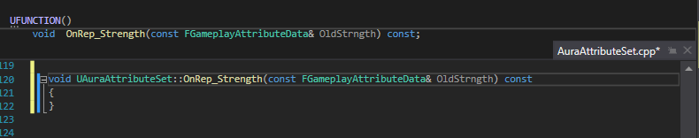

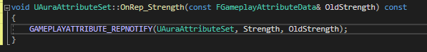

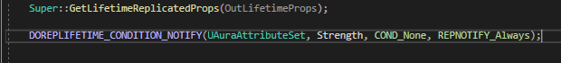

And then we apply for the other attributes

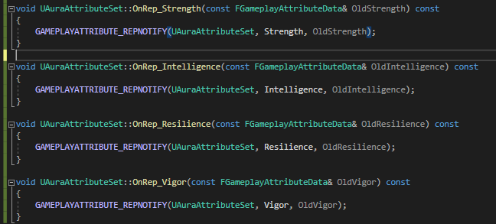

So, the purpose of this exercise is to initialise from a datatable. To do this we need to expose the ability system component to BP, so that we can set a specific asset, the datatable, on that component

To od this we need to open the Aura Player State, where the ASC is located

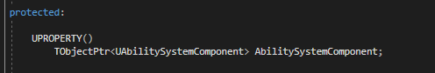



The ASC properties are now exposed in the player state:

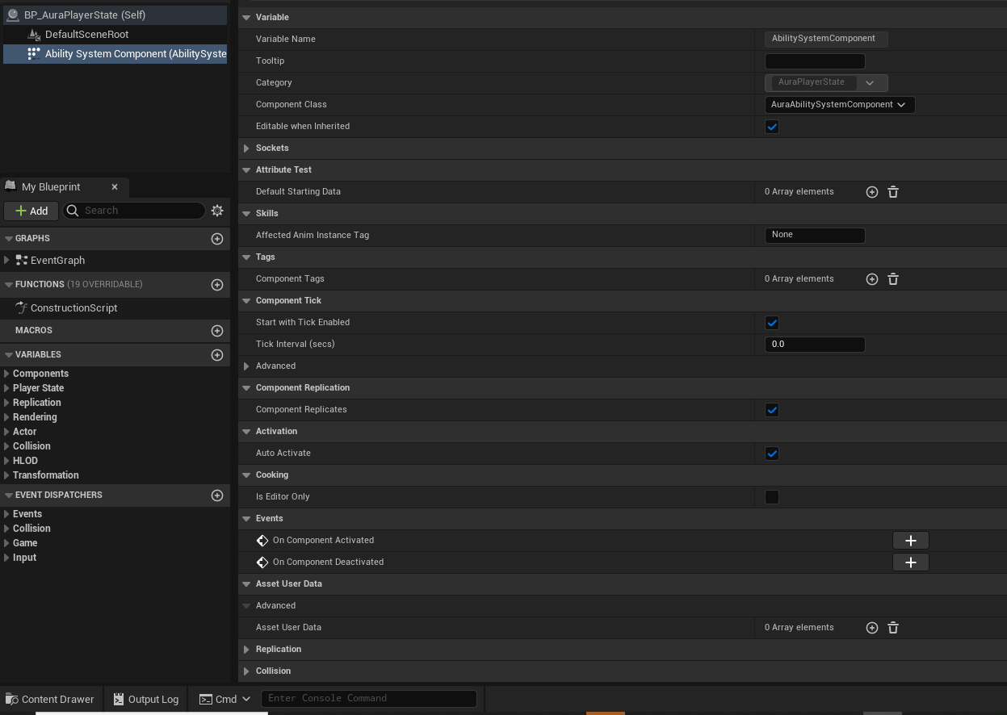

To use a data table to initialise some attributes, we have to add an element to the array Attribute Test called Default Starting Data

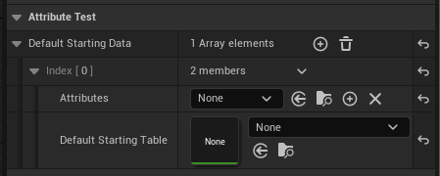

You can choose attributes

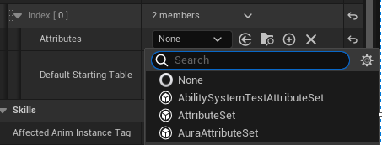

And a data table to use

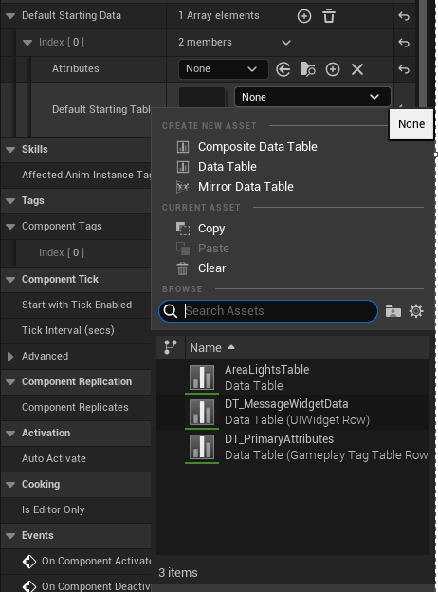

But you can’t just use ANY data table – it needs the correct row structure.



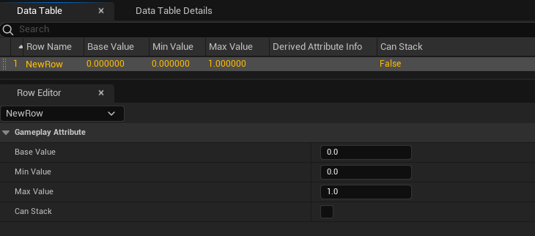

Row name is specified by the Attribute Set, a dot, and the attribute name



Base value:

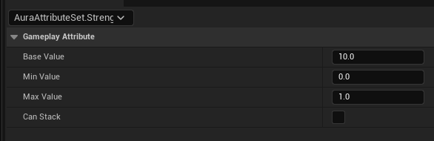

And now back in the player state:

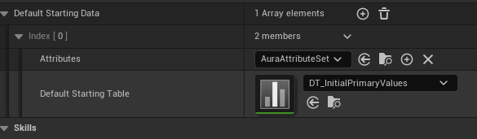

And now in-game:

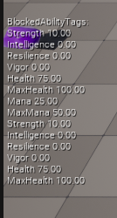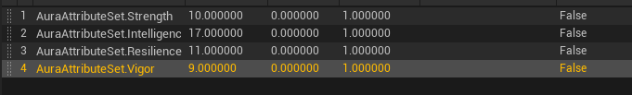

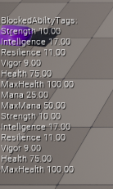

The struct:

From the parent AttributeSet.h:

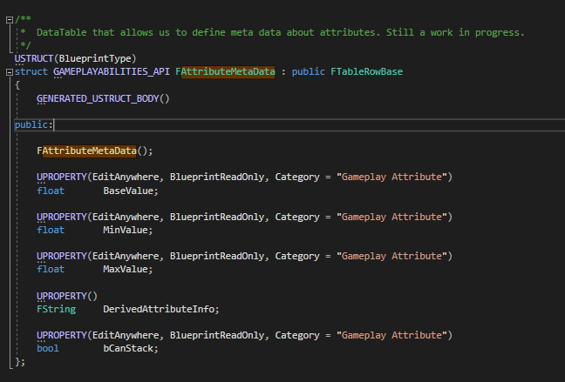

Currently it’s mostly useful for setting the initial value of attributes; it implements no functionality for a minimum or maximum, it just inits the values

It’s limited in application, but this can be pretty useful for some cases; You just fill in the values and the ASC does the rest

Most people prefer to initialise using a Gameplay Effect on game start though

# Initialising Attributes with Gameplay Effects

After disabling the data table previously used, go to AuraCharacterBase.h

Protected:

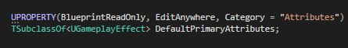

So, we have a DefaultPrimaryAttributes, now we need a way to apply these attributes

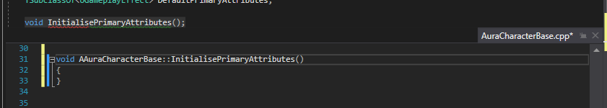

How to define.

First, if we’re going to call something like ApplyGameplayEffectToSelf() or toTarget, we’ll need a GameplayEffectSpec to apply. Which we can create because we have a class for our DefaultPrimaryAttributes

So work backwards.

Call the fn to apply the effect

We can always get our AbilitySystemComponent, assuming that it’s valid at the time of calling, and from it call ApplyGameplayEffectToTarget()

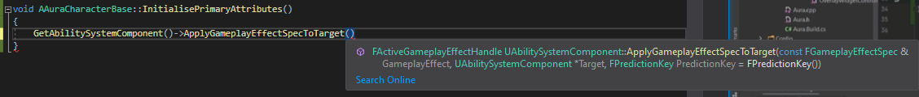

To apply the Gamepla Effect we need a GameplayEffect Spec. Asa reminder, the function for this is MakeOutGoingSpec(), taking in a UGameplayEffect, a level and a context handle.



To get a context handle:

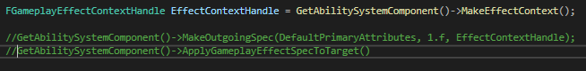

Now we have our Context we can pass it into the next line:



This returns a Spec Handle, which we can pass into the next time. However, it’s not enough to just pass in the handle, we need to use the internal variable Data. Data is a wrapper, so we need to then call Get(). This returns a pointer, but the function does not take in a pointer, so we have to dereference it!

Finally the second argument required is the ASC



Finally these can be made consts

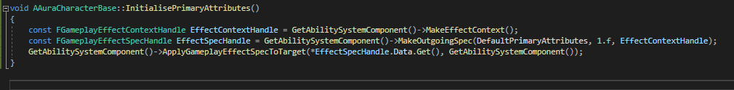

This applies a GameplayEffectSpec to a target Abilitysystemcomponent

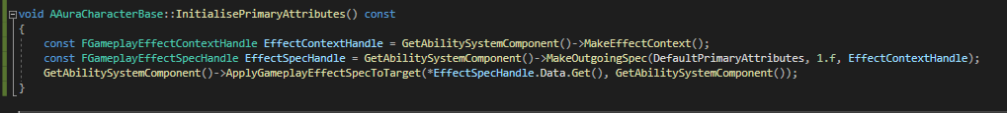

There should be no problem as long as all these values are correct, and we can check them

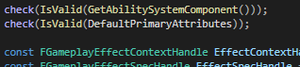

Now we have the function, where do we call it?

It can be called in different circumstances, depending on if we are the aura character or the enemy

For the moment, we’ll do it for the character

Since we created this effect in the base character class we can inherit it in the character class

Unlike the InitAbilityActorInfo this does not need to be done on both sever and client, it only needs to be done on the server, because all of the attributes are marked to be replicated, so if we change them on the server they change on the client as well. We can do it locally as well to save waiting for replication, either is fine

If we do this in InitAbilityActorInfo, we know that the ASC is valid at this point. So we know it’s safe to call it here; lets do it after the Hud

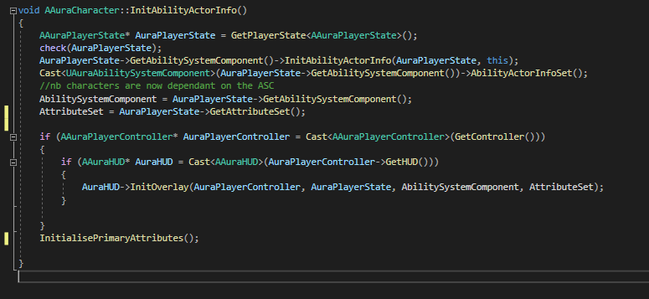

Now all that remains is to make sure we have that effect and set some default values

Run in Debug mode

Error: 1 Remember to forward declare the UGameplayEffect class

Error 2: DefaultPrimaryAttributes is not a function! Change line to:

Check(DefaultPrimaryAttributes);

Now in the editor we need a GameplayEffect to initialise the PrimaryAttribute values

This will be specific to the Aura Character, and eventually we’ll have different types of characters that start with different values

For now, we’ll create just 1 GE; an instant, applied once, with 4 modifiers, one for each primary attribute

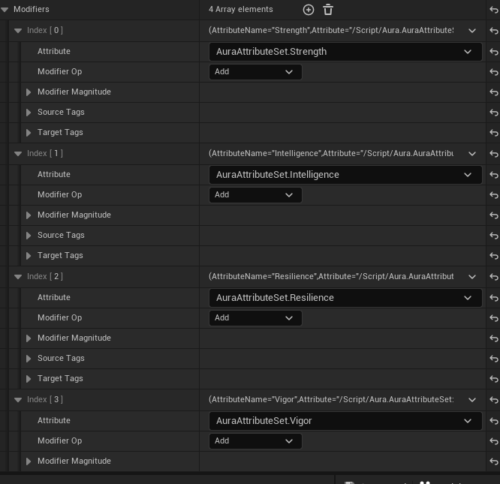

Modifier opp is not add, it’s Override

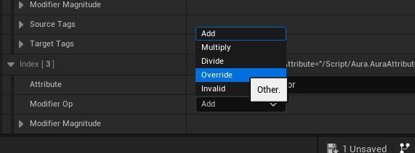

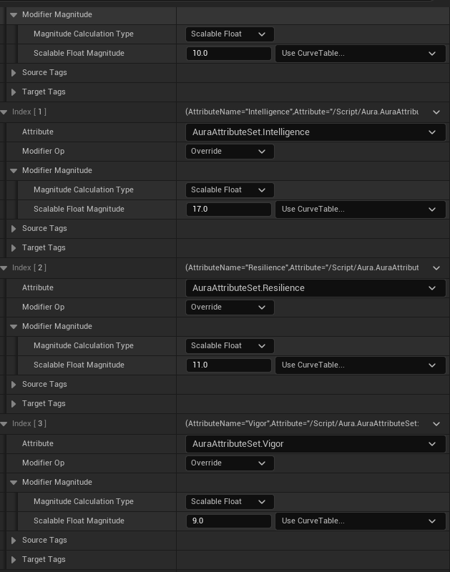

Once this is done we need to set the GE effect on the aura character(otherwise game will crash)



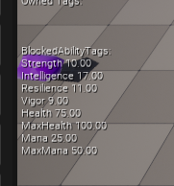

# Attribute Based Modifiers

So far all GEs are using scalable floats for modifier magnitudes

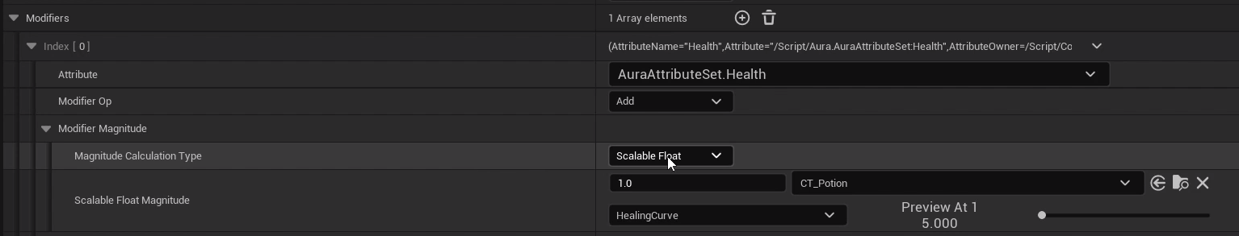

But there are other options:

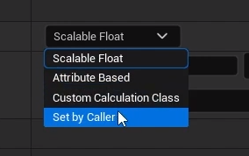

The one we’re looking at right now is Attribute Based

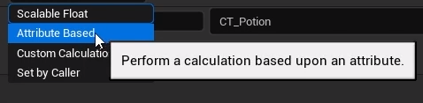

Ability to have an attribute change based on other attribute values

Easy to have an attribute that derives from other attributes

New actor that applies a test effect that uses attribute modifier magnitude calculations

So, create new actor and GE:

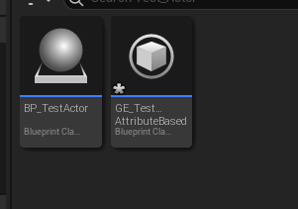

In TestActor:

Add Box collision, set collision box to visible and make the lines a bit chunker, maybe 5 thickness.

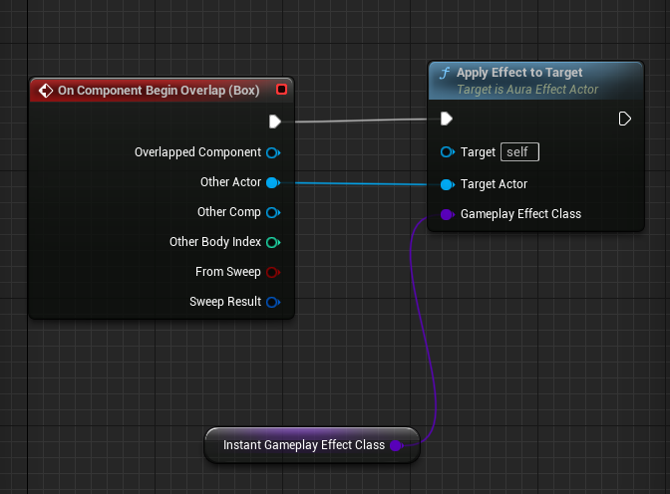

Set applied effect to:



In GE Test AttributeBased:

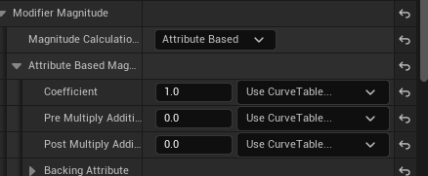

Expand Backing Attribute



Effect is applied from something to something, so we can capture the attribute effect from the source or from the target

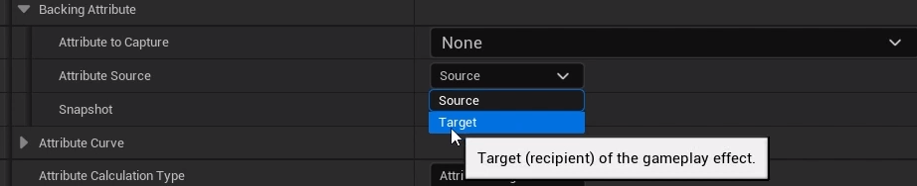

In this case capturing Target

For later: snapshot controls when to capture the attribute, when should we use that attribute’s value? When the effect was created, or when it was applied? Snapshot determines this

Attribute to capture:  
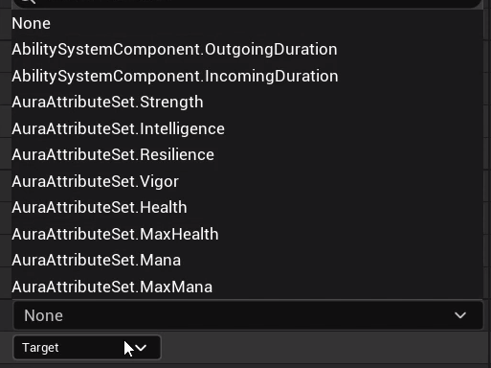

We’re taking from the target (Aura) so we’ll be using one of her attributes

If we pick Vigor then we will be applying the value to health with an Add opp, so Health is now Health + vigor

In action:

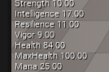

Health 75 default, + 9 vigor is now Health 84

With all the options present here this can get complicated quickly, and we can add multiple modifers as well!

What if we add a second modifier to the effect that also adds Str to health?

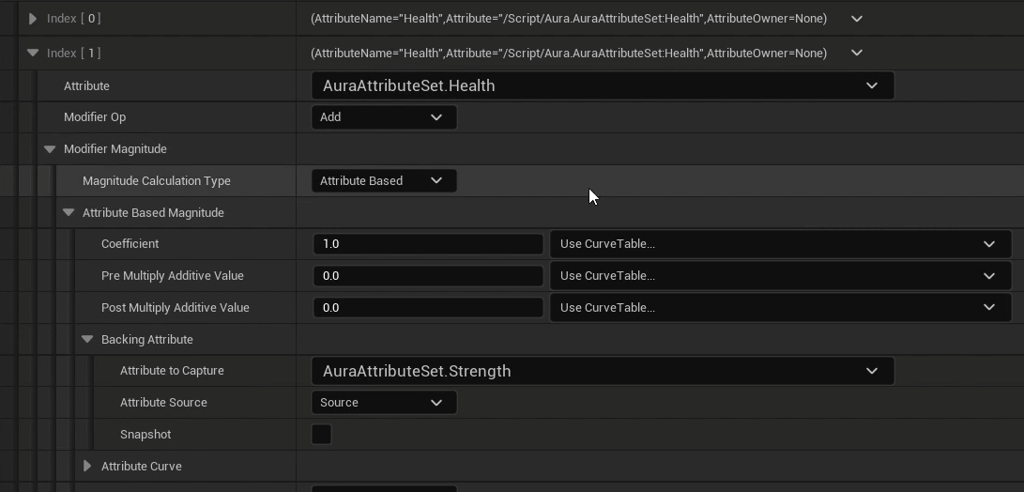

How it’s 94!

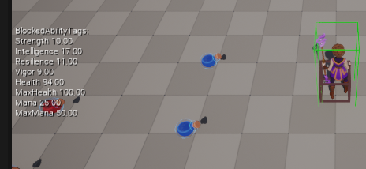

It’s pretty intuitive when the mods are all Add, you just add them all together. But it’s important to understand how they work and how the order is taken into account!

# Modifier Order of Operations

Adding a third additive Attribute mod based on Resilience boosts the Health over 100; pretty predictable

75 +9 +12 +10 = 106, over the 100 cap

I’ve dropped default health to 10 for the sake of simplicity

So, initialising health to 10. We can add a modifier to a GE effect, choosing an attribute to affect, choose an operation like Add and for Backing attributes we choose vigor itha value of 9. So This means Health will be 10+9 19.

A second modifier targeting health, adding backing attribute strength is another 10, so 29

Similarly adding Resilience is +12, so 41

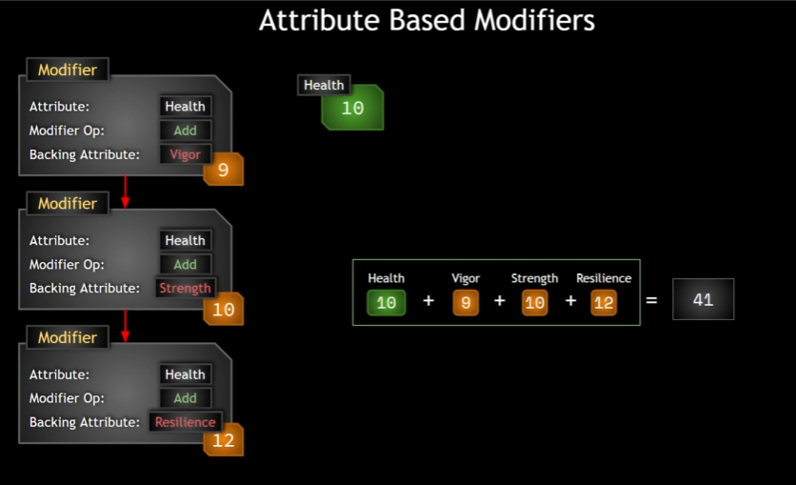

These happen in order, so the first modifier is applied, then the second then the third

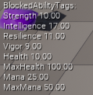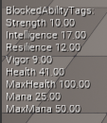

But what if we change the Str modifier to multiply?

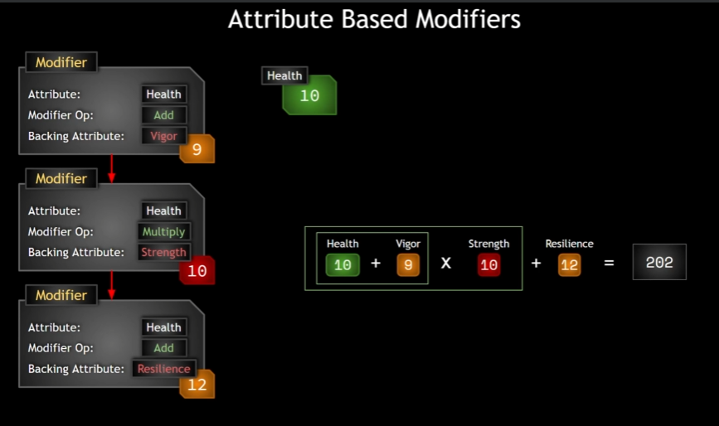

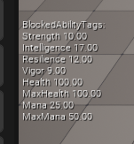

(Health is clamped)

If we comment out all the clamping lines:

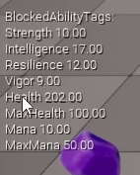

What if we now change the Resilience, third modifier to divide?

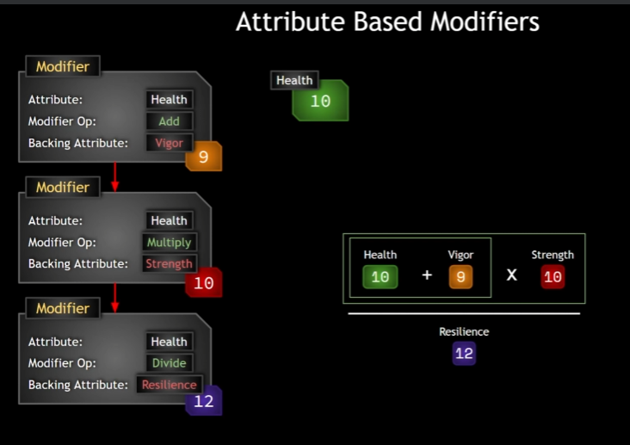

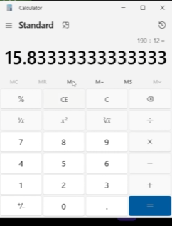



Let’s add a 4th attribute, Max Health

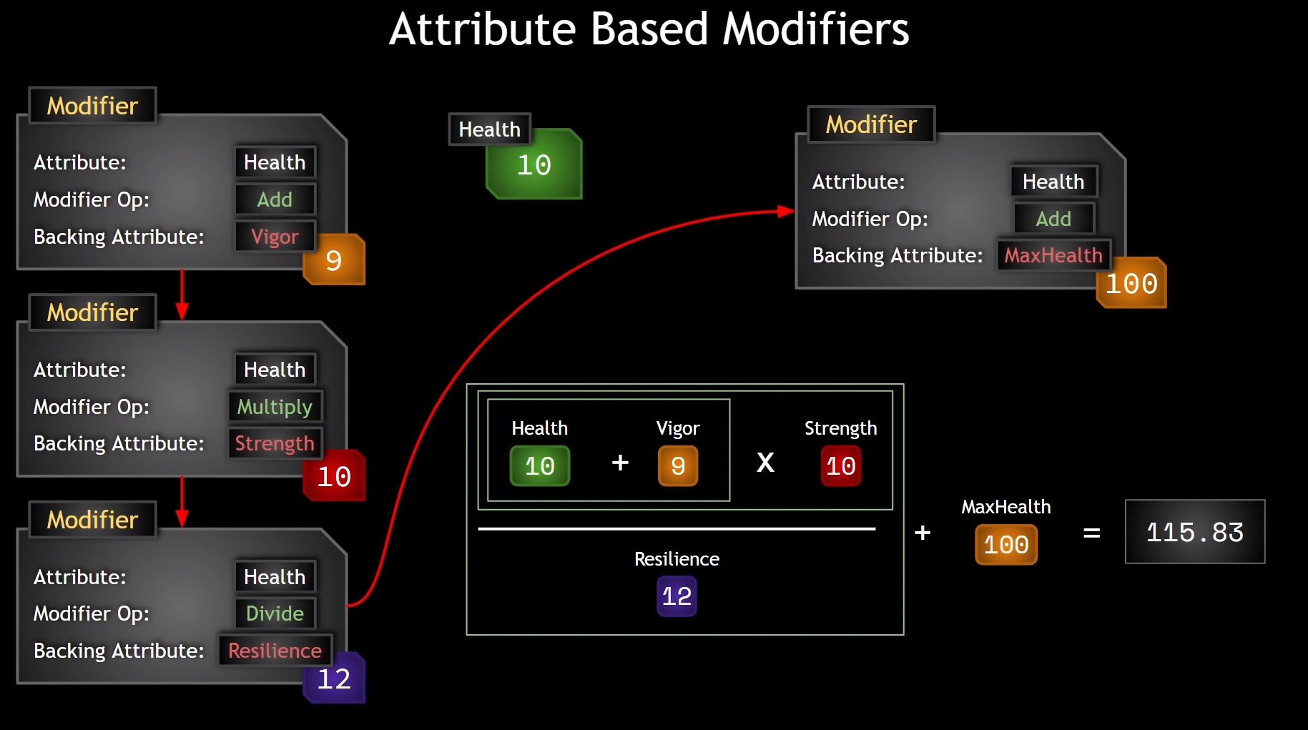

So, order of operations is fairly straight forward. What about the effects of these additional values?



# Modifier Coefficients

Just being able to multiple, add, divide or subtract an attribute from another attribute isn’t quite enough!

What if you wanted to Add to health a value of Str * 10? Or Str * 0.1? Or Str * 0.1 + 12?

This is where we do it

So we have a Coefficient, a Pre multiply additive value and a post multiple additive value.

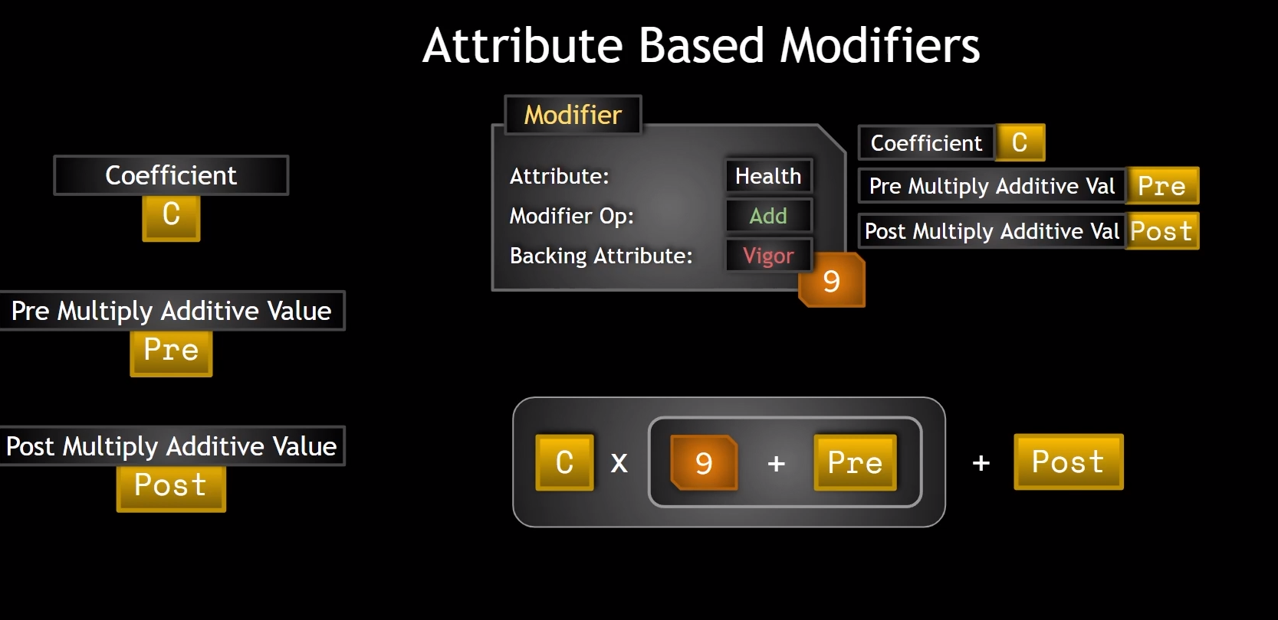

So 10 + 9 is actually 10 + ( Coefficient * ( 9 + Pre)) + Post !

Pre and Post default to 0 and C defaults to 1

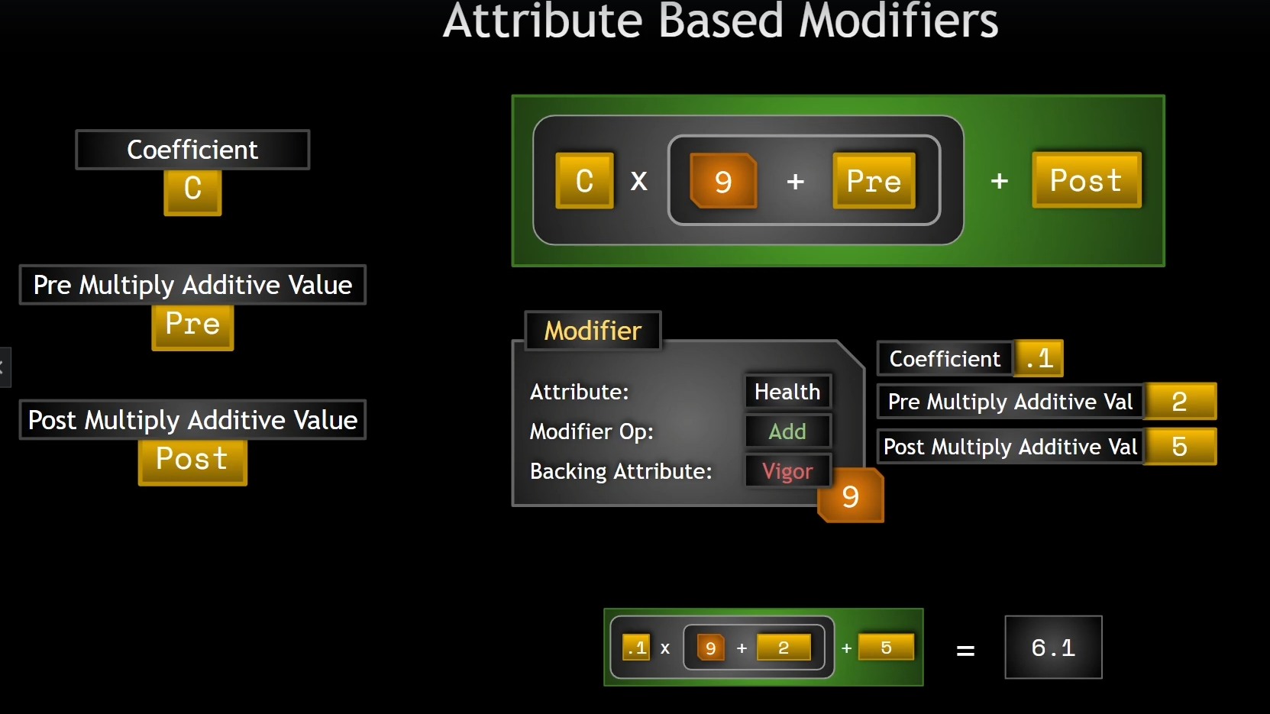

Applying numbers to ALL the modifiers might result in this:

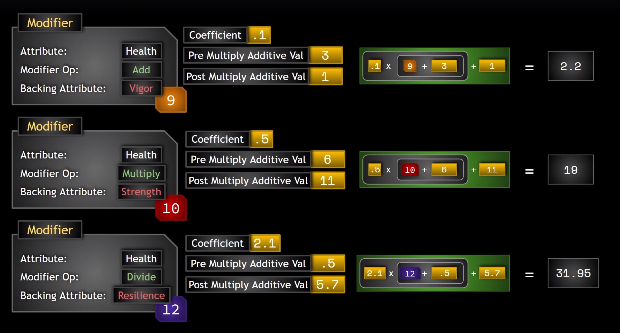

For a final result of:

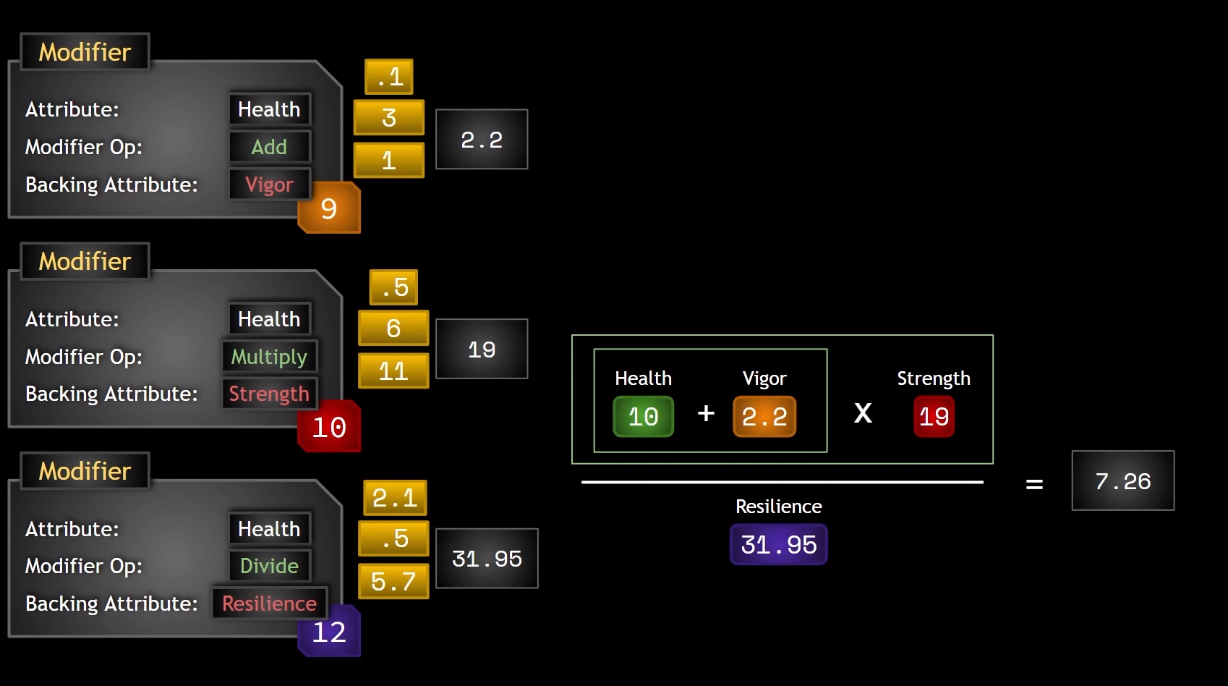

This allows for a nice level of complexity and flexibiilty, but we can’t use arbitrarily complex and arcane calculations (other functions in GAS do allow this)

# Secondary Attributes

Now that we know how to apply modifiers to affect attributes, and that those modifications can be backed by other attributes we can create derived attributes: attributes that depend partially or entirely on other attributes.

From a design perspective it’s important to lay out what all the attributes in the game should be doing.

So far we have categorised some attributes as Primary that do no depend on others and are standalone. We can increase or decrease them based on game mechanics but other attributes in some way or another depend on them. Decided at the Design level

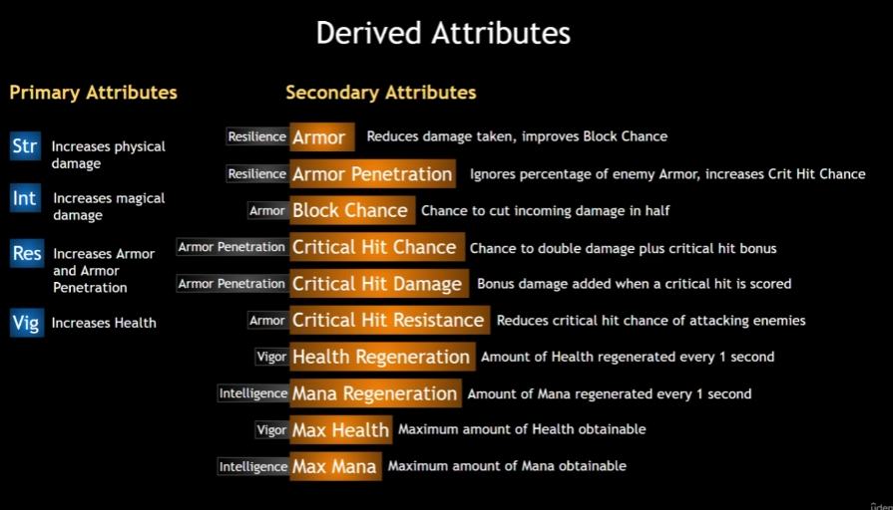

As you can see, some secondary attributes are dependent on other secondary attributes.

Also, Max Health and Max Mana are now secondary instead of Vital

To do:



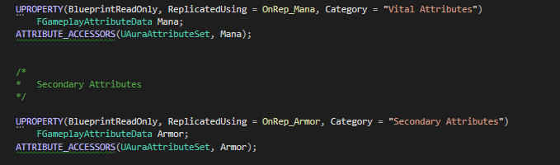

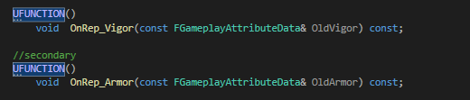

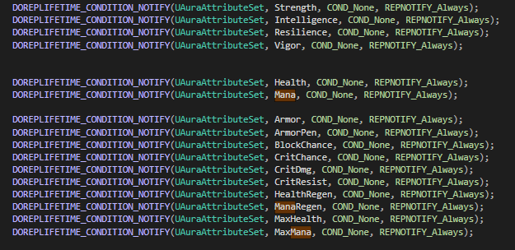

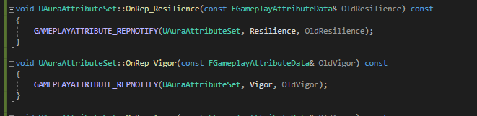

# Derived Attributes

Now we have the secondary attributes we need to make them depeendant on other attributes, for example when Resilience changes, armor does too

The way to do this is to apply an infinite gameplay effect at the beginning of the game, perhaps when applying all the startup effects in the character class?

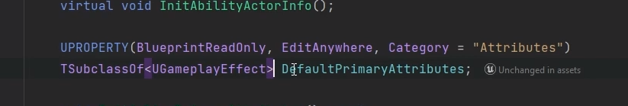

We have a Gameplay effect class in Character Base for the Default Primary Attributes; we can just copy this



It’s important to initialise these attributes AFTER the primary have been initialised!

However, since it’s an infinite effect, whenever the Primary attributes change, the secondary need to change too. So we need also to apply this effect

We’re handling attributes in the AuraCharacter, so lets look at that again



This is called in the initabilityactorinfo, but it’s defined in the base class

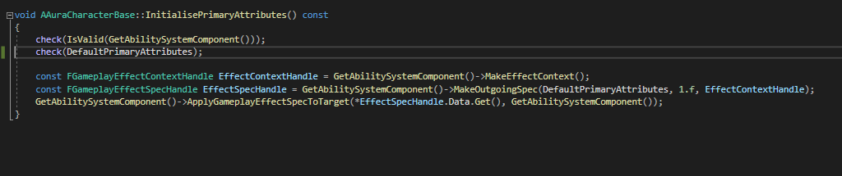

We can just do the same for Secondary attributes



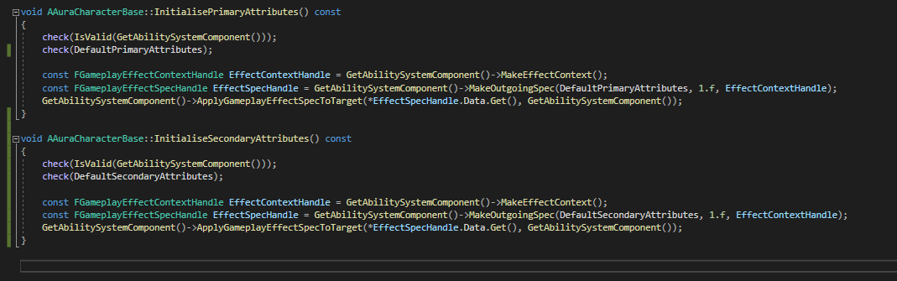

This code will work just fine BUT…there’s a lot of very similar code here, so we have the chance to refactor to make things more efficient!

New general function:

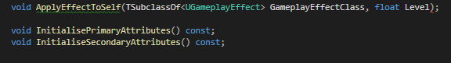

We’ll take in a gameplay effect class and a float for level, and other than that we’ll just do what we’re already doing in the Initialise functions!

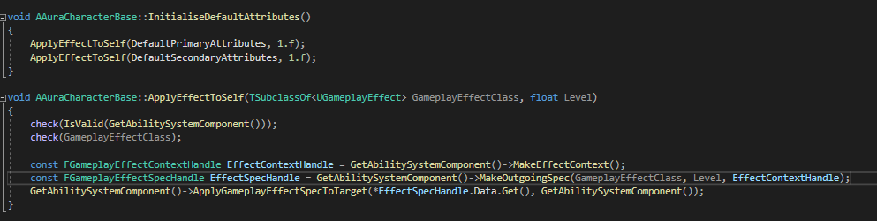

These functions can both be const.

Now we need only call InitialiseDefaultAttributes in the AuraCharacter instead of initialisePrimaryattributes

We now will need to make a new infinite GE to initialise the attributes, and we can remove the initialise for Max Mana and Health in code as they are no longer needed



Duration infinite, so we always see primary attribute changes reflected in derived attributes

Does not run every frame

Add the secondary to the Aura Character BP



And then we set up the GE

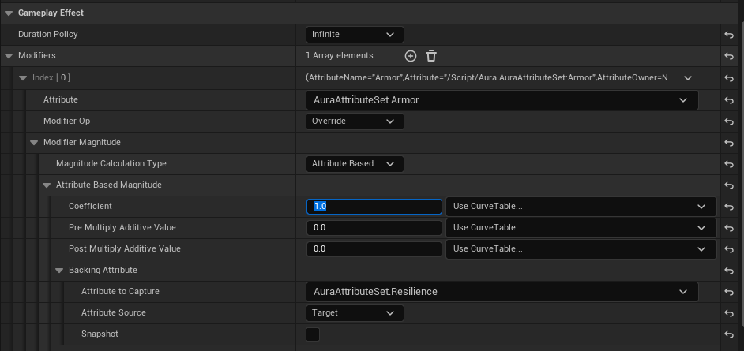

Derived attributes should be infinite so they always update and Override

The math choices and captured attribute are up to design

NB, at this point armor is already overriding to 12 from Resilience with base value 0!



If we want a base value of armor before resilience, that’s the post multiple value:



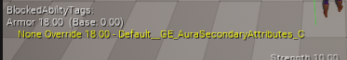

If we set a coefficient of 0.25, armor is equal to 6 + 12/4





If we pre-add 4

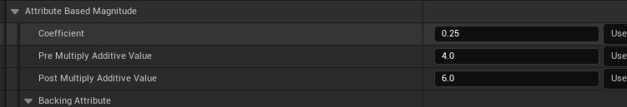

12+4 = 16 * 0.25 = 4 + 6 =



As the resilience changes, armor will also change!

Using the test actor:

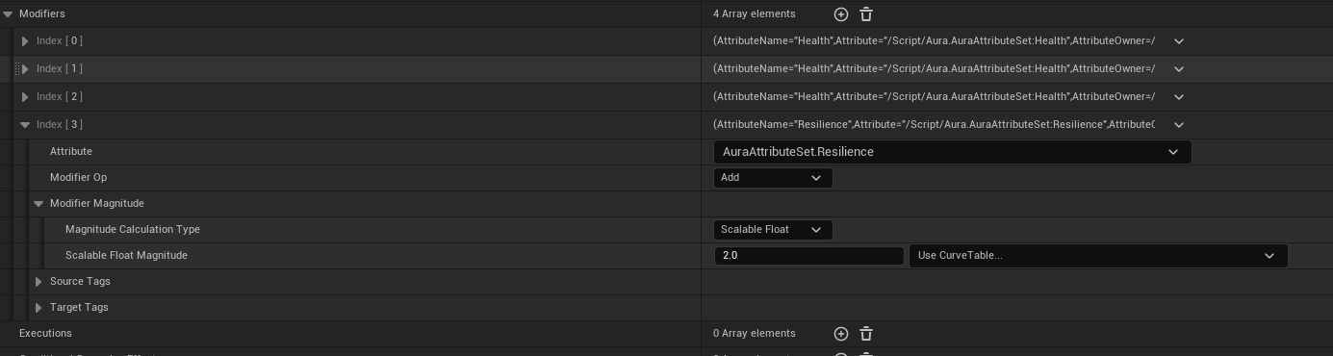



Resilience goes from 12 to 14, so Armor is now 10.5

RPGs are about equations, and mathematical relations and it’s not uncommon to test theory as boardgames before we do videogames!

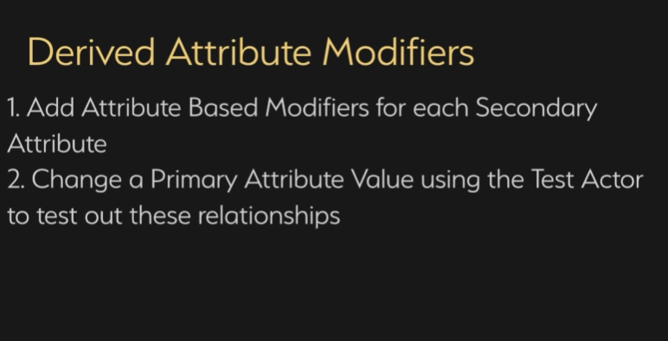

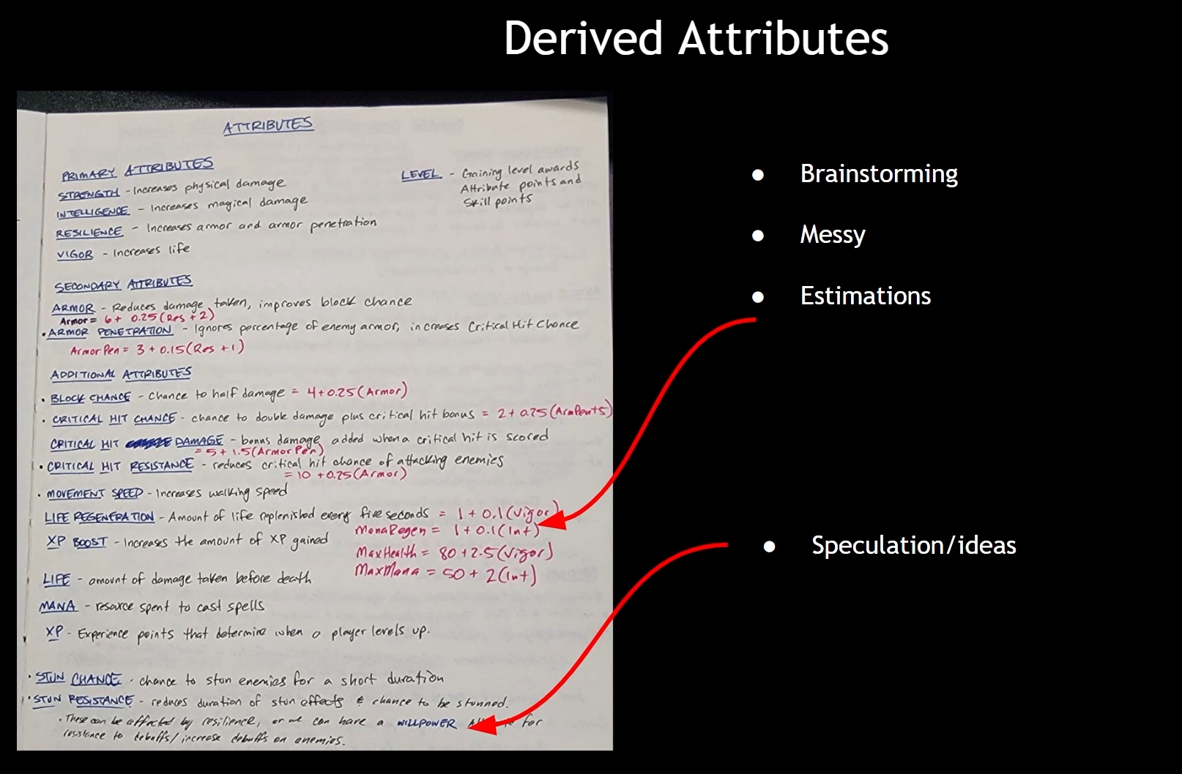

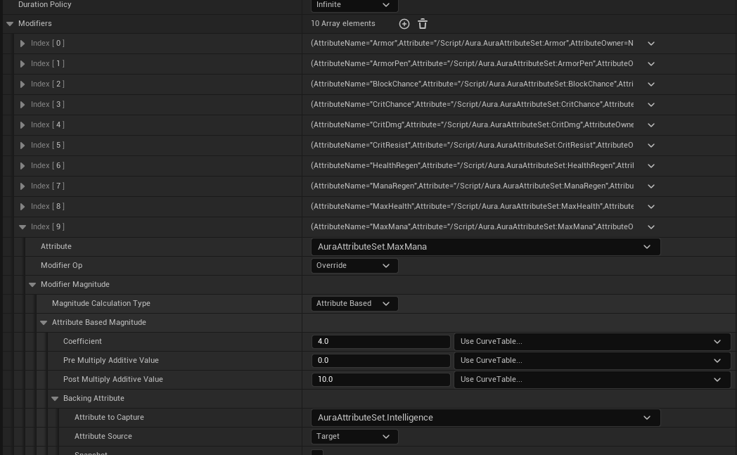

At this point the secondary attributes are crowding the screen, so we’ll output to a widget soon

# Custom Calculations

Now we know how to have attributes backed by other attributes we’ve seen the limits of modifiers.

Lets say we have a modifier and want to override max health in an infinite gameplay effect so Max Health is dependant on other attributes. For example a base value of 80 + (2.5 * Vigor). Easy enough. But what if we have another value, like the player’s level, and we want to include THAT in the calculation for example + 10* level

Level is not an attribute in the attribute set, but vigor is. How do we use Level from somewhere else, like in the player state?

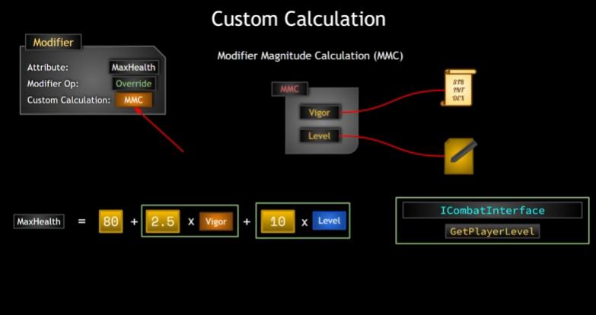

We use a custom calculation, or rather a Modifier Magnitude Calculation (MMC). This is a class that we can create that determines the calculation used for the modifier. So we wrap the calculation into an MMC and set that on the modifier.

Attributes are numerical values that have complex interrelationships with other attributes and other things in GAS, level is more of a progress counter.

MMC will be able to access info within it related to source and target of GE.

MMC should be general, not dependant on classes like character or playerstate. Dependent on abstractions like interfaces.

This way anything that implements the Combat Interface (participates in combat) can access the Getter function for player level

This means the level does not have the be a variable on the player state, it could be on individual character classes for enemies. Implementation specific to different cases, but the MMC is general

More flexible code = best practice.

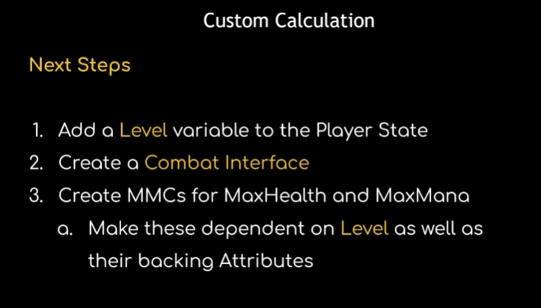

# Player Level and Combat Interface

In Player state new private int32 variable for Level

Level will be replicated and have it’s own rep notify

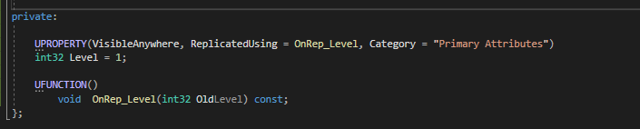

We’ll need to override the existing GetLifetimeReplicatedProps  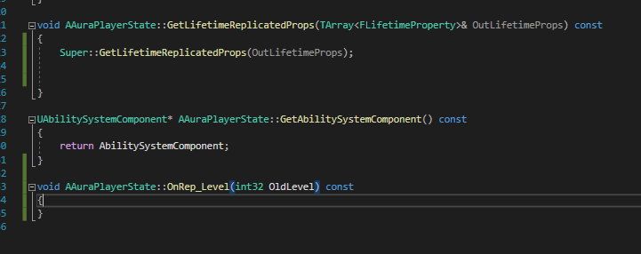 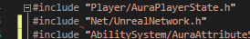 

Level is now a replicated variable

The playerstate is where the level will reside, but we want that to only be the case for the player character

For enemies, their level should not be on a player state because they don’t use them; should be on the enemy itself!

We want it to be editable by Design

We’re not replicating this at all for Enemy, because we’re only checking the level on the server side.

Same Variable layout

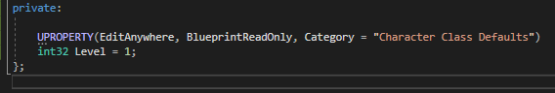

To access and use this we’ll use an Interface called CombatInterface

AuraEnemy has a Level and AuraPlayerState has a level, and we want and interface to retrieve that implemented on the character class so any character class can call it, and then the child class will determine how to retrieve it – either from the player state or return from the character itself.

Nb the variable is show as private here, but we need it to be accessible if it’s BP readable, so move to protected!

So, the combat interface

CombatInterface will be shared between enemies and player controlled character

The default combat interface will have one function, returning a default value of 0:

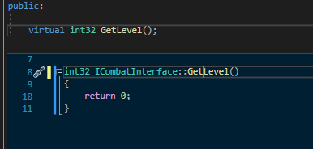

Then we’ll implement it in the BaseCharacter class, which does not *need* to implement it, but because the base character does implement it, we can override in the AuraCharacter and Enemy classes

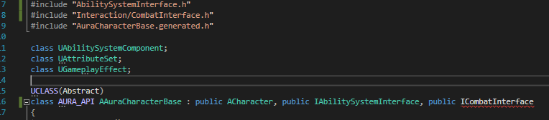



We’ll first implement in Enemy:

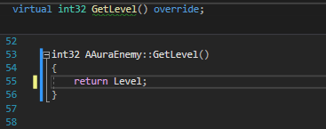

We’ll just return Level

For AuraCharacter it’s a little different, because Level is on the playerstate:

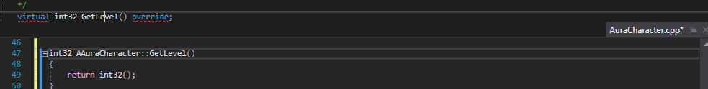

For this we’ll need to get the player state. It looks like we’re doing this already in InitAbilityActorInfo so maybe it’s possible to just copy, or possibly refactor somewhat?

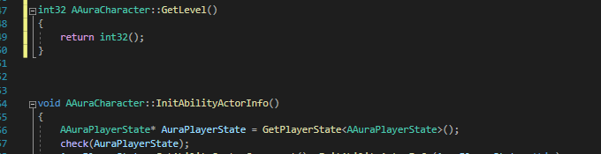

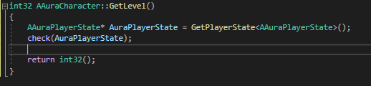

In AuraPlayerState Level is private, so we should make a public Getter in PlayerState to retrieve that level variable

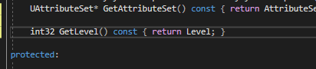

In this case we’re hiding a function; there’s a function called GetLevel on the actor class. This will likely be a problem for ALL the other classes so we’ll rename the function to GetPlayerLevel on all fronts (CombatInterface, the CharacterBase, Enemy and Character)

Also, we’ll mark the Playerstate version with FORCEINLINE



FORCEINLINE is a small optimisation; it can be overused. Doesn’t make a huge difference at runtime; whenever we call GetPlayerLevel the preprocessor will replace that function call when preprocessing before the compilation step with the function body (the variable itself).

No harm with small things like this, but big things can be too much

So now we can just add the return to the playerstate:

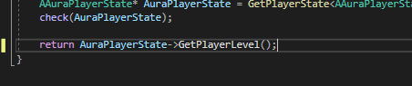

Also AuraPlayerState can be a const here:

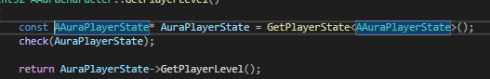

So now AuraCharacter and Enemy implement GetPlayerLevel()

Now we have an Interface we can use to easily get the player level if we need it in a custom calculation class

At this point there seems to be a problem using TObjectPrt for ThisActor and LastActor in the mouseover interface:

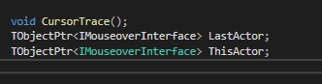

So we’ll make them raw pointers instead

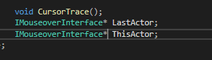

Also the CombatInterface won’t allow virtuals so:

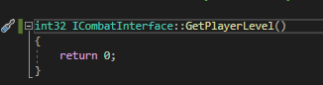

# Modifier Magnitude Calculations

Now we’re going to make a custom calculation class so we can have Max Health and Mana not only dependent on other attributes, but other variables that are not attributes.

This will involve making changes, not only to the GE, but also, because we’ll now use a Custom Calculation class, we need to create that class

It’s a C++ class, so it’s here:







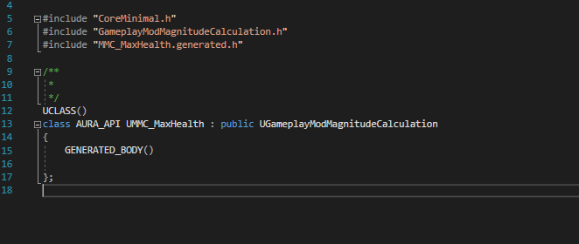

So, the value of MaxHealth will be determined by the calculation we create here

A ModMagCalc needs it’s own constructor



How do we calculate our custom calculation? Where do we put it?

It goes in a specific virtual function that we override, returning a float (it returns the result that our modifier should produce)

From the parent class:

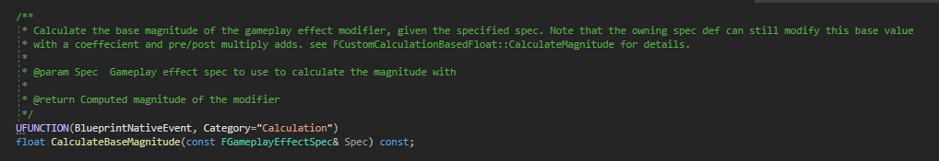

Our function:



The argument it takes is a FGameplayEffectSpec& Spec that will be the effect spec of whatever gameplay effect has a modifier that uses this calculation

So we have access to that Gameplay Effect Spec, which means we have access to all the data inside it!

ModMagCalcs can capture attributes; they have access to all the stuff in the spec, but can capture attributes as well. But to do that we have to create a variable to do that!

Variable type has to be of type: FGameplayEffectAttributeCaptureDefinition

This is a struct which defines what attribute we’re going to capture:

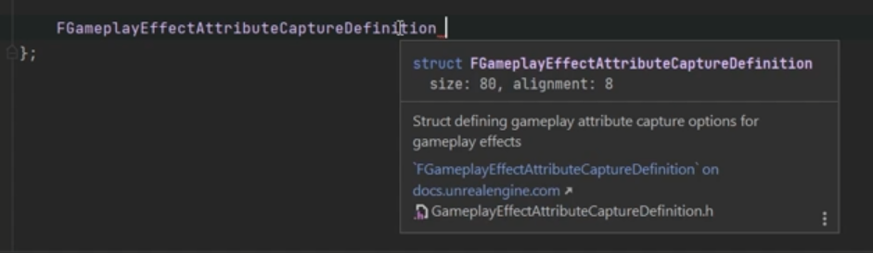

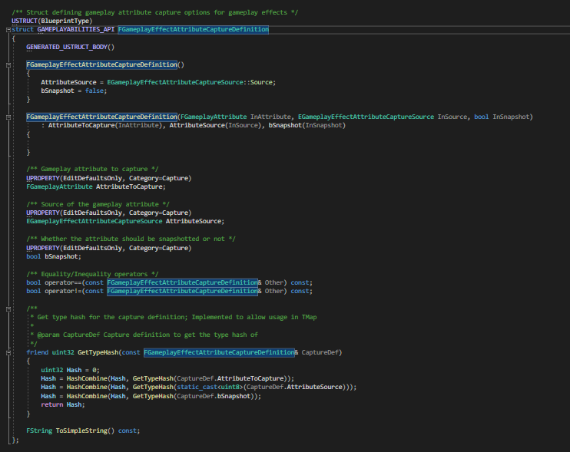

We’ll call this VigorDef

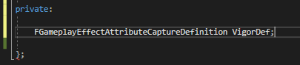

Define the function:

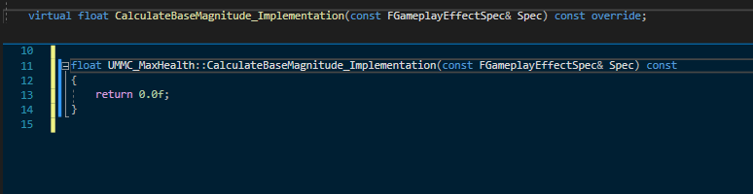

(0.0f is default return)

VigorDef is currently an empty variable, so we need to make sure we capture the attribute, which we do in the constructor



And we can specify the attribute with a static function from AttributeSet



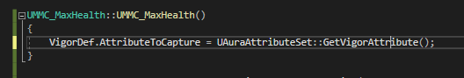

As a reminder, in the attribute set we have Attribute_Accessor macros like this one:



And one of them is the Property Getter:

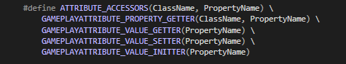



This macro results in the creation of GetVigorAttribute(), because we called it with the vigor attribute. GetVigorAttribute() is a static function, which means we don’t have to have a pointer to the object, we can just call the static function to get the attribute itself.

If we’re capturing Vigor we have to define whether we’re capturing from the target or source.

In this case, we’re applying the gameplay effect FROM the AuraCharacter TO the AuraCharacter, so they’re the same, but we’ll specify anyway using an Enum

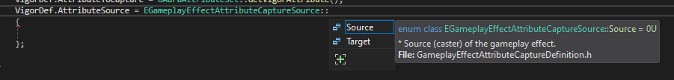

We should also decide whether or not to SnapShot the attribute:

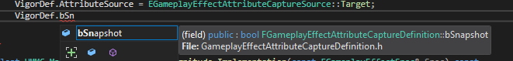

Snapshotting is all about timing, when do we want to capture the attribute? On GE Spec creation or application? In this case they happen One after another immediately so it doesn’t matter, but it might later – for example we add a spec to a fireball and send it flying; if it hits something it applies the spec

Snapshotting captures the attribute right away; not snapshotting is getting the true value at the time of application of the effect

After setting these properties on VigorDef the MMC needs one of it’s variables, which is an array of attributes to capture, we need to add VigorDef to it.

From the parent:

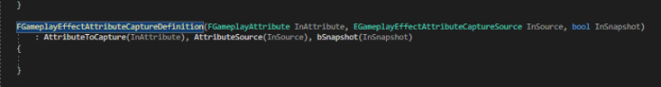

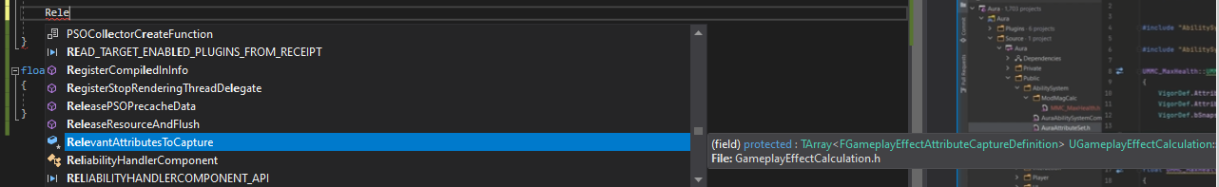

It’s a TArray

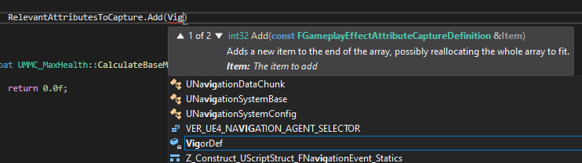

And we just call Add()

So we have created this VigorDef, we’ve captured it and now added it to the array of capture definitions. Now when the modifier is execute and the mod applied, we can be sure to have Vigor captured from the target at time of application

Now let’s look at the _Implementation function

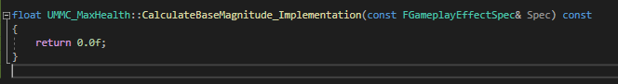

We can do all sorts of things here, like get any tags the source or target have for example. Here’s how to do that:

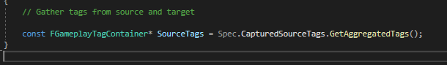

We can do the same for Target tags:

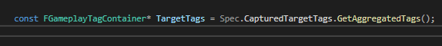

To capture an attribute and get it’s magnitude we need to create an 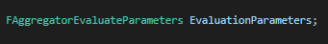

When we create one of these the EvaluationParameters object has it’s own SourceTags and TargetTags, so we pass those on

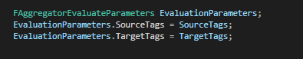

These are parameters we have to pass in to a specific function to capture the attribute we are interested in





The last part, the value for magnitude, is a non-const reference. This function will set that float = Vigor at time of capture. So make a locate float and init to 0, then pass in vigor

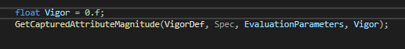

After calling this function Vigor will have the value of the vigor attribute on the target

We’ll take vigor and clamp it

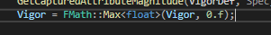

(returns the max value between Vigor and 0, so Vigor is always at least 0)

So far so good, we have Vigor, but we want the MaxHealth to depend not only on Vigor but also the player’s Level – that’s the entire point

So, we can get the the Source object of the GameplayEffect from the spec

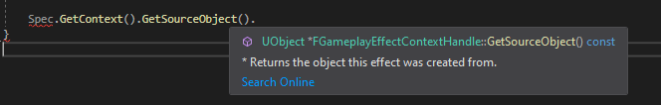

The Source object is a UObject, and as long as the GE has a source object we can cast it to that interface

In this case, the Source Object is the Aura character, so we cast to the combat interface

(Header required)

We can save it to a local variable

Then we make another variable to hold the player level:

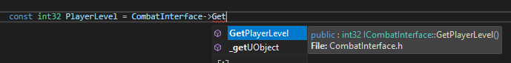

Now we have the Level and Vigor we decide what the custom calculation returns. It returns a float, so we need a return statement (previous it was return 0.0f)

We can calculate the value return for this modifier however we want.

Example:

Base value of 80.f + (Vigor * 2.5f) + (10.f * Player Level)

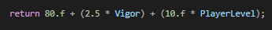

Currently:

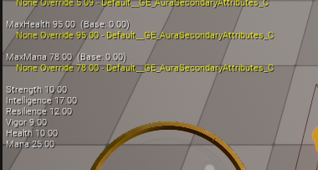

Change in GE_SecondaryAttributes:

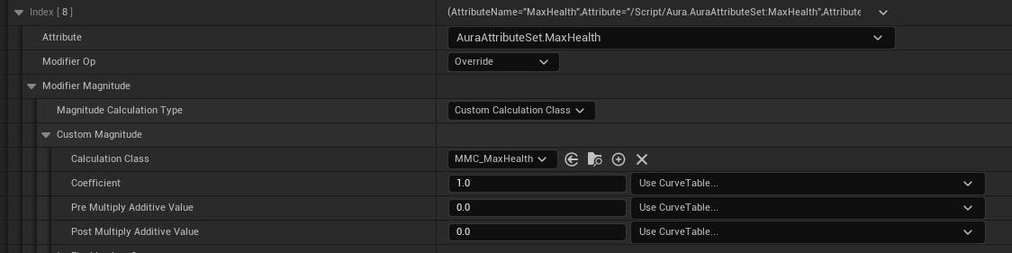

Nb: you can even assign coefficients and pre and post multiply additives to our custom calculation!

Additional: we captured the Source and Target tags – we can choose Require and Ignore tags here!

Source Require tags – tags that must be present on the source

Ignore Tags: if present, cannot apply this modifier

So, previously the Max Health with the attribute based calculation was 95

Uh-oh! An exception!

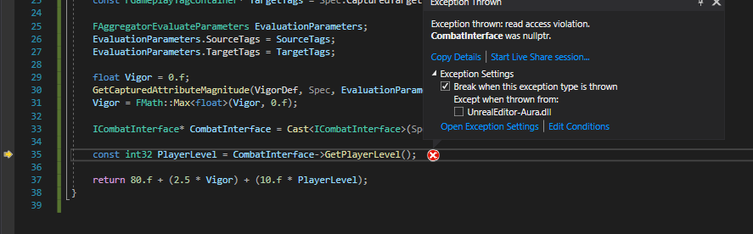

This is because the source object is a nullPTR!

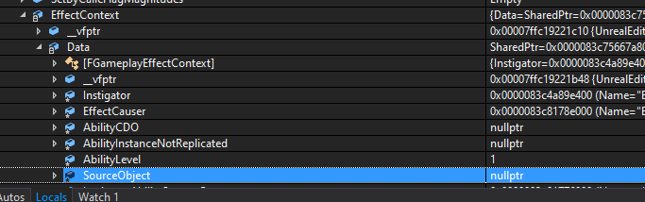

Makes sense, we didn’t set the source object!

But where do we do that?!

AuraCharacter base; reminder:

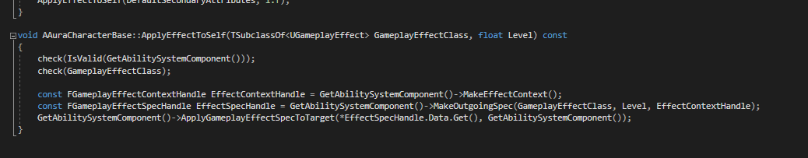

Where have we previous set a source object?

Aura Effect Actor:



In character base we have an FGameplayEffectContextHandle already. We made it const previously…but now we need to change something on it!



We’re using (this) again, because the object itself (Aura or the enemy) is the class that has the implemented interface function GetPlayerLevel from the CombatInterface, that why we need to use the character itself.

Now when we apply the effect to itself we’ll have a value source object.

Without a source object the vigor was starting at 0

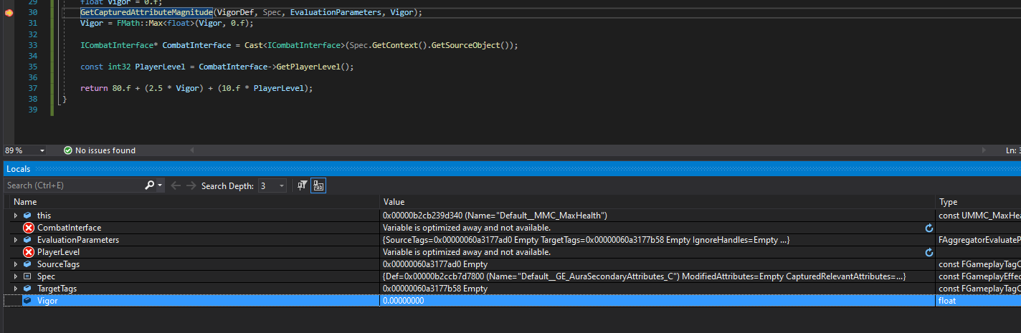

Now it’s: 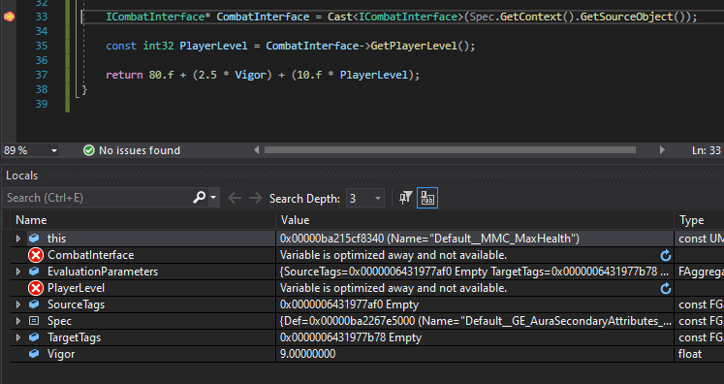

And the source object is set:

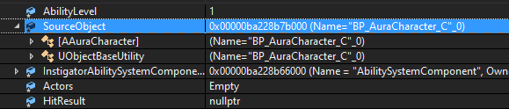

Maxhealth:

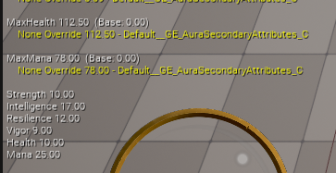

NB: since the code checks for the Combat Interface, the function is agnostic as to the source of the Level; it will pull level directly from Enemy class when it’s applied to Enemy characters

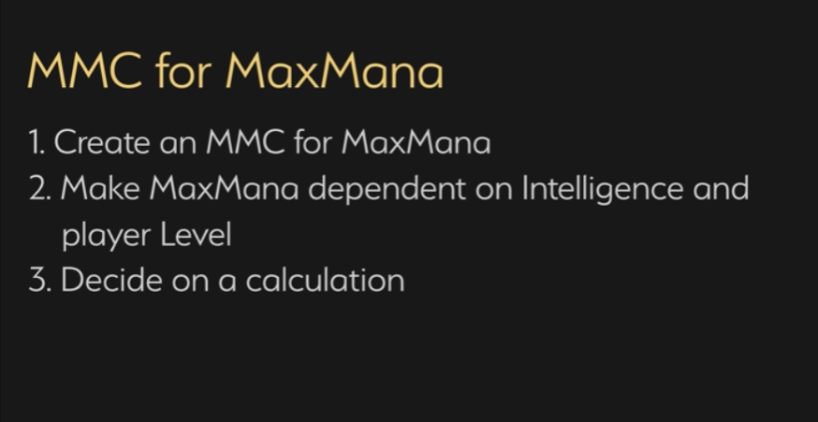

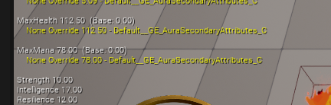

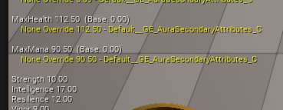

Done!

# Initialising Vital Attributes

Currently Health and Mana are initialised at low values, which are hardcoded (this was for testing). Not ideal in release however, better to have them initialise at the Max Health and Mana! But how?!

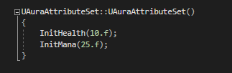

We’re not calling them in the constructor any more

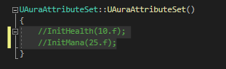

MaxHealth and MaxMana are dependent on other attributes; hard to tell what that’ll be if we hardcode it. So we won’t; we’ll set them after the Max values have been set. Timing is important!

Gameplay effects have worked well so far, so let’s do that here as well. Does not need to be infinite, it can be instant



